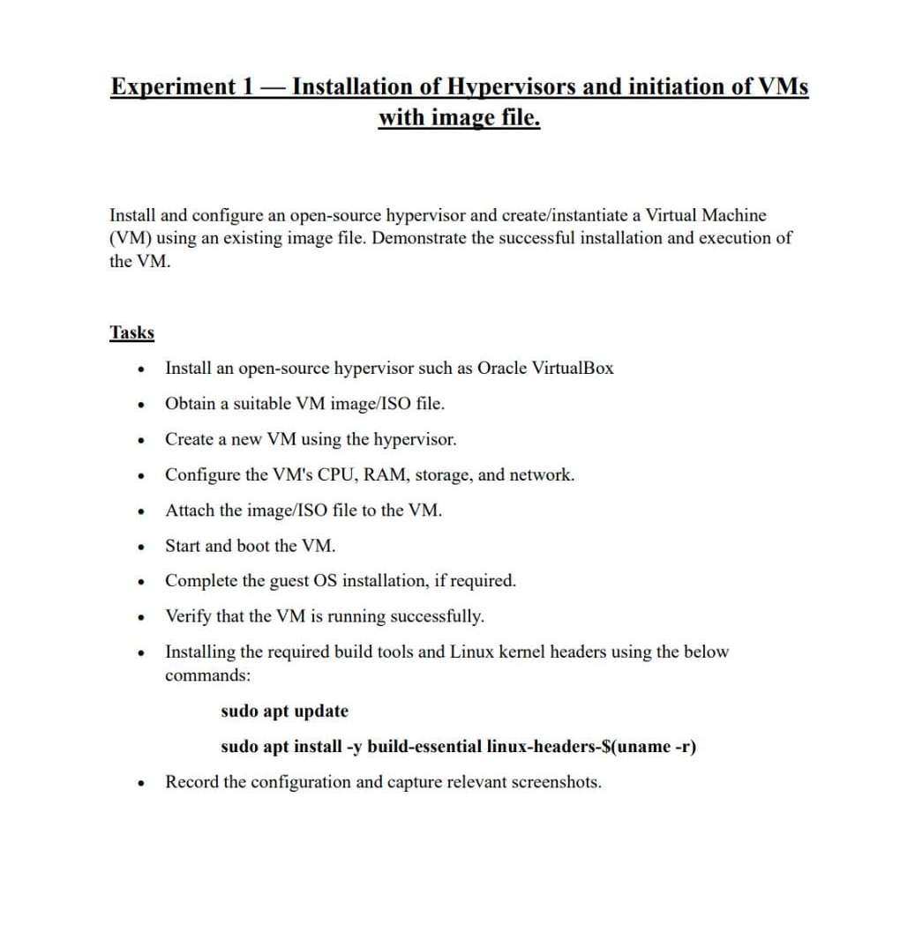

- Installing and opening Oracle Virtual Machine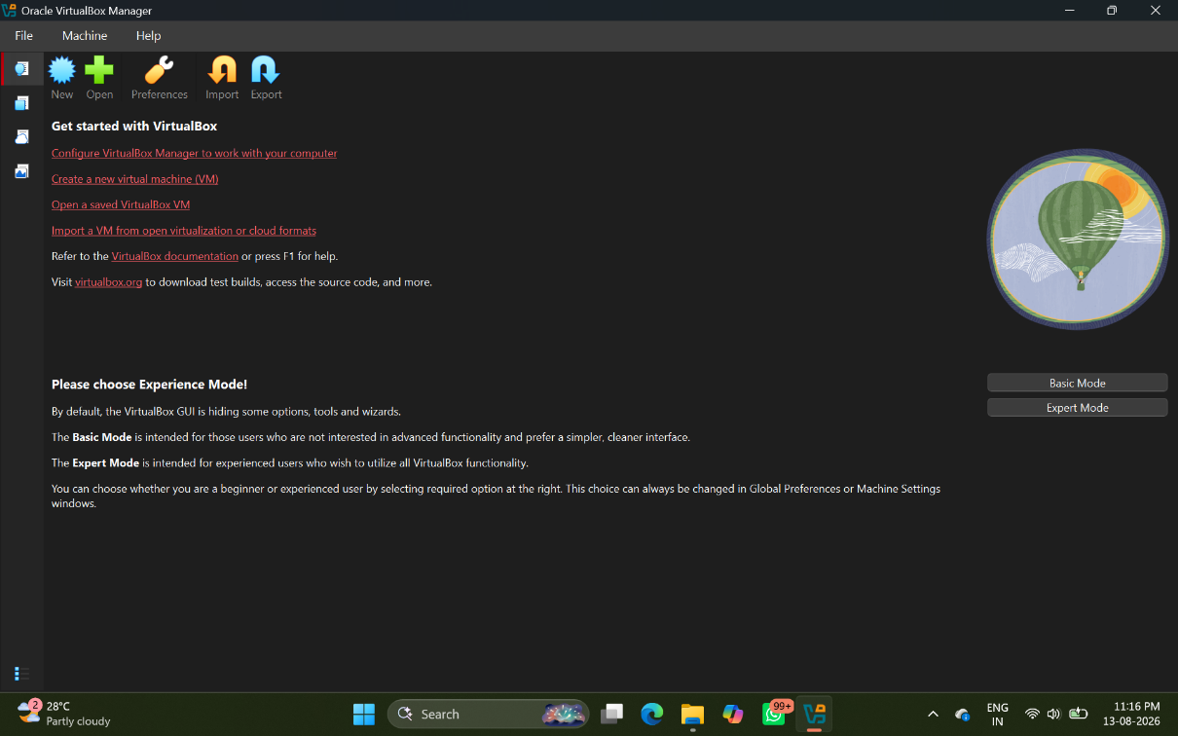

- Uploading ISO file for OS installation in VM
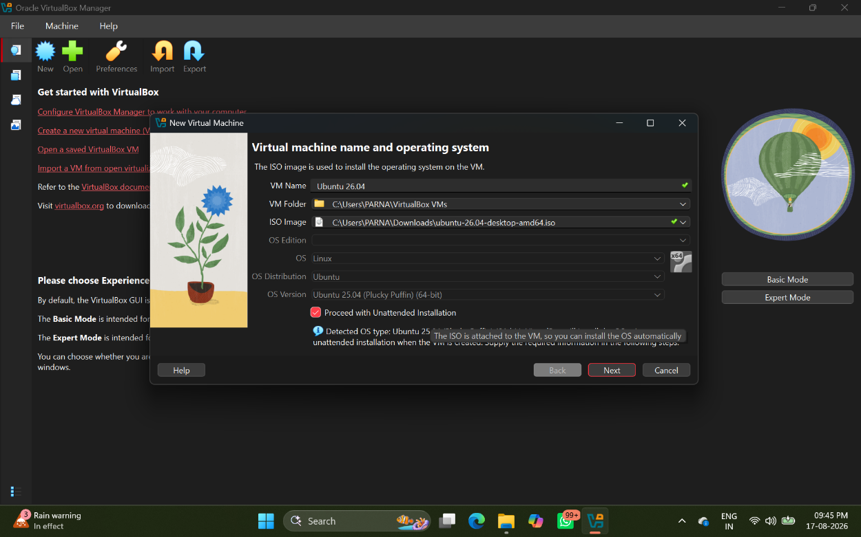

- Hardware setup for VM
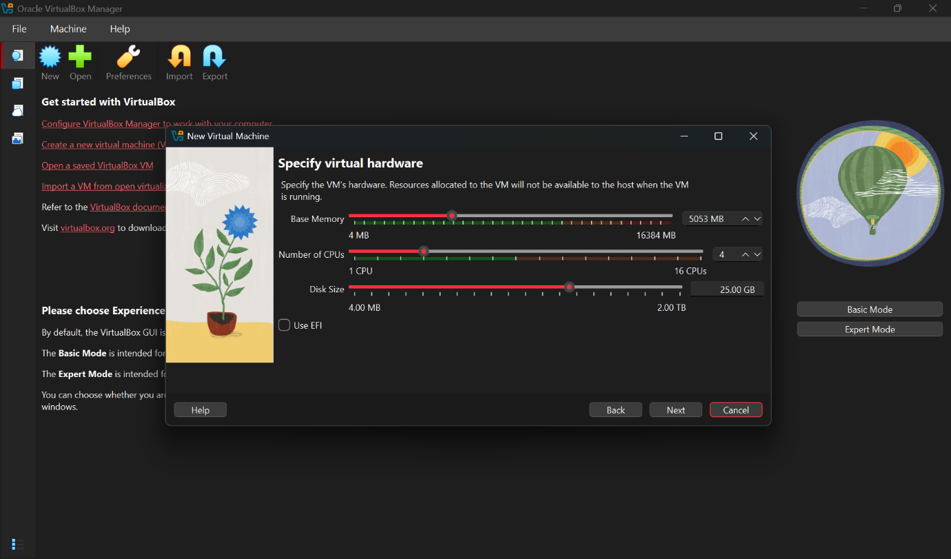

- Virtual Machine Configuration
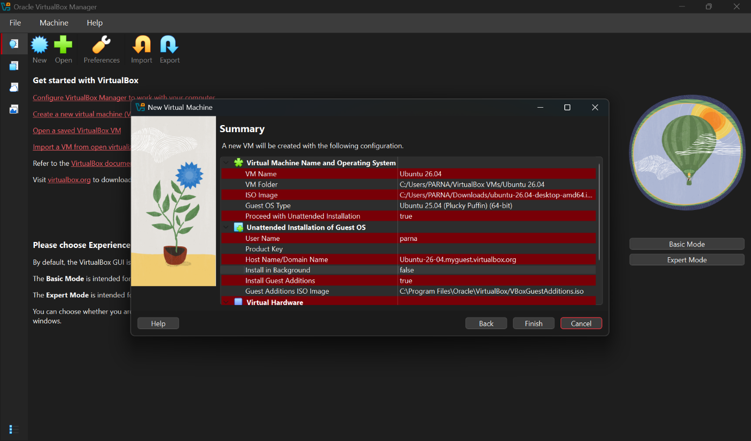
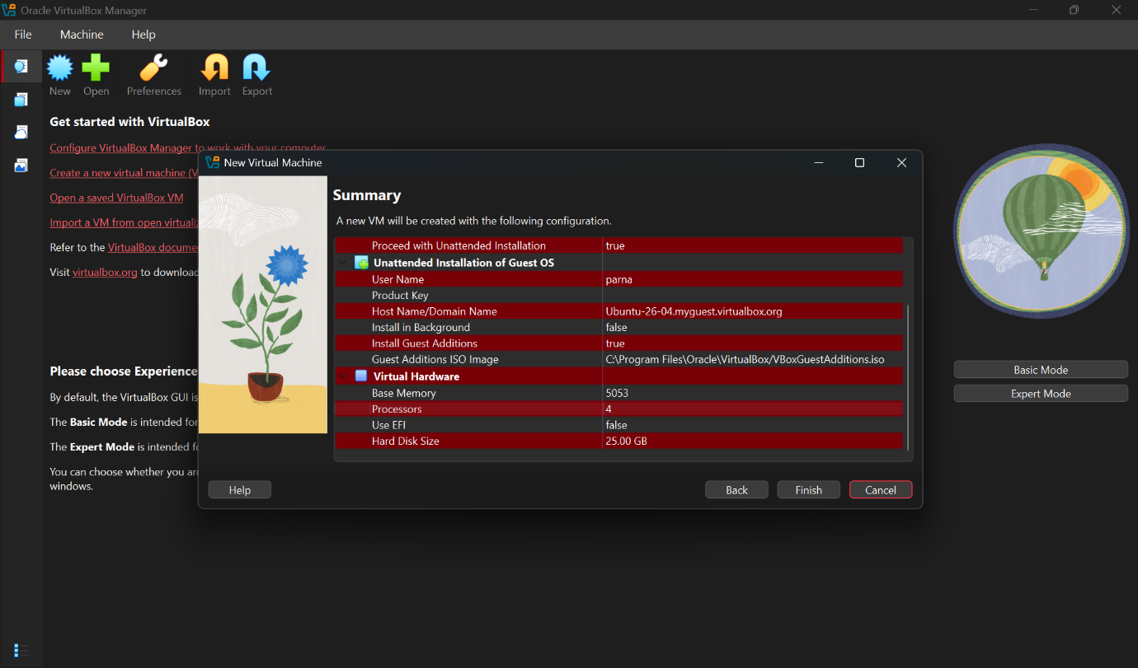

- Ubuntu installation in VM
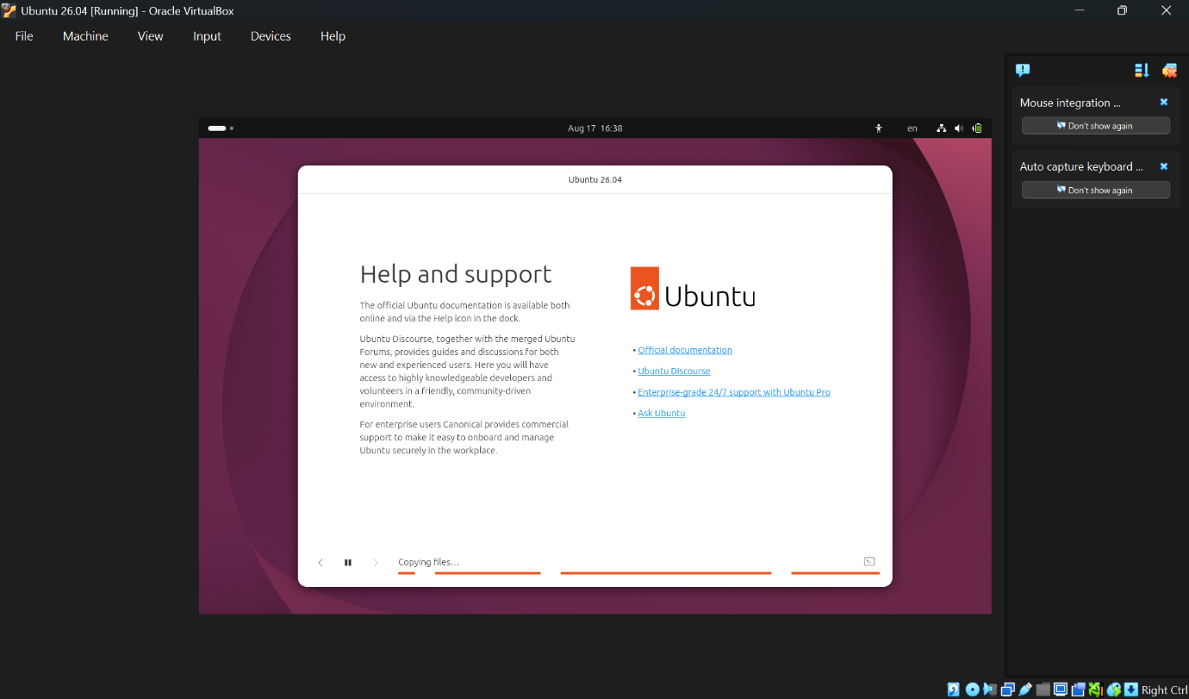

- User login in Ubuntu
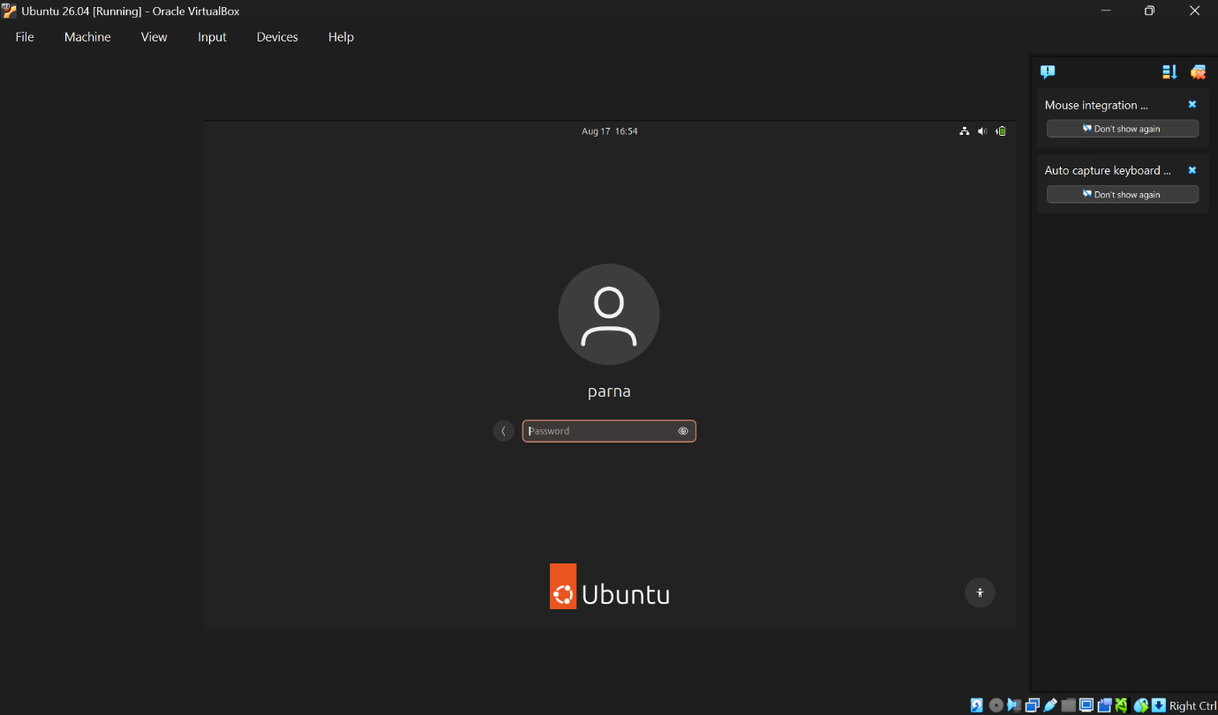
- Ubuntu Home Screen
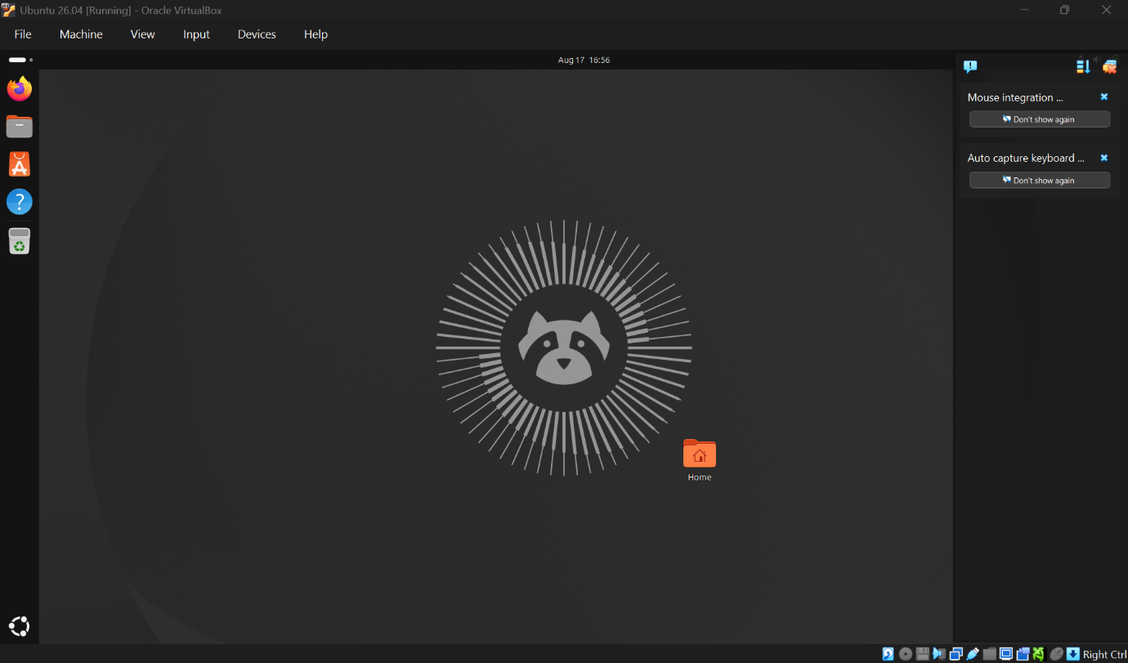

- Install build tools & kernel headers using following command
a)sudo apt update
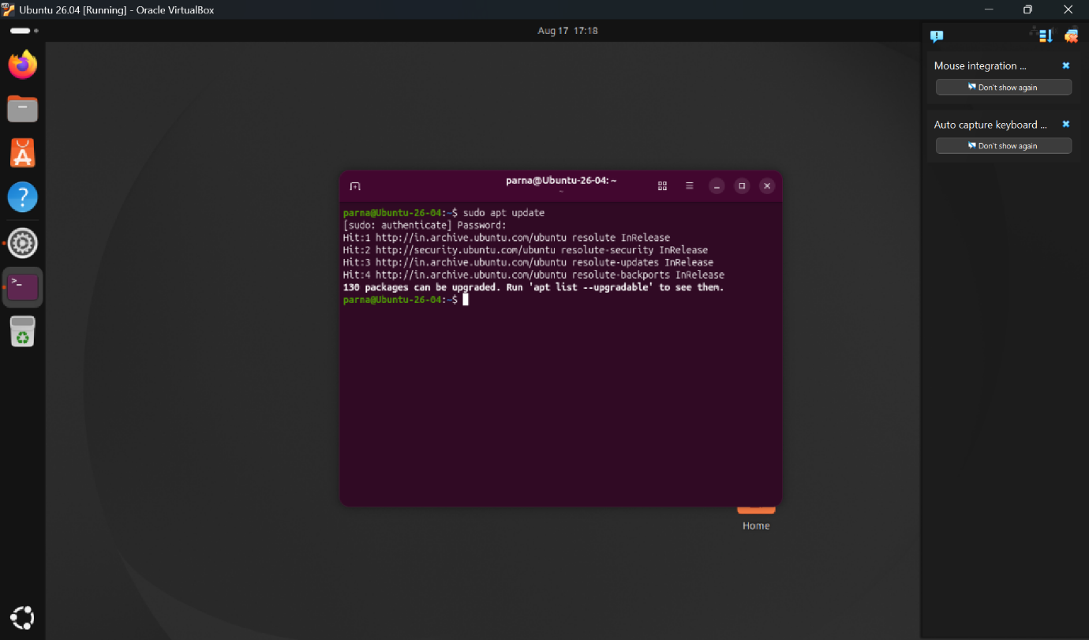
b) sudo apt install -y build-essential linux-headers-$(uname -r)
Error: Unable to locate linux headers
Solution:
